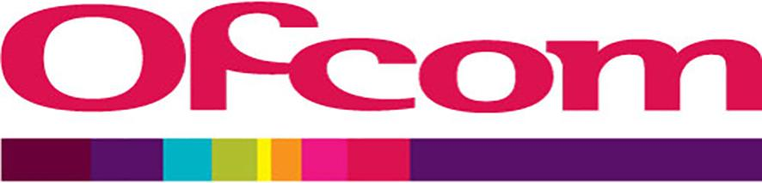
Motorsport Licence Application Form - IM1300.5

Important Information

By providing your details on this application you are confirming that you have read and understood Ofcom’s Privacy Statement. Visit https://www.ofcom.org.uk/about-ofcom/foi-dp/general-privacy-statement for more information.

If this is your first time applying for a Licence please complete Part 1 and Part 2 of this application.

If you already have a Licence with Ofcom you only need to complete Part 2 of this application.

PART 1
Please complete the relevant sections of this application in full. Mandatory sections are indicated with an * and missing information may cause delays in processing your application.

1A. Who is the Licence to be issued to?

*Full Name / Company
*Address
*City or Town |  |  |  |  |  | *County
*Postcode |  |  | *Telephone |  |  |  |  |  | *Email

1B. Please provide the address and contact details of where this Licence and general correspondence should be sent?

Same as above
Surname
First Names
Address
City or Town |  |  |  |  |  |  |  |  | County
Postcode |  |  |  | Telephone |  |  |  |  |  |  |  |  |  | Fax

PART 2

Please complete the relevant sections of this application in full. Mandatory sections are indicated with an * and missing information may cause delays in processing your application.

* Licensee:
* Event/Customer Reference/Annual licence:

* Contact Name |  |  | * Phone |  |  |  |  | * Email
* On Site Name |  |  |  |  | * On Site  Phone

*Sites | Site Name & Address | National Grid Reference or Postcode | Start Time | Start Date | Finish Time | Finish Date | Ongoing Annual Start Date

A

Location/s of Base Stations and Aerial Positions on Site. (e.g. Broadcasters Compound)

Frequency Information
(Transmitters should not normally be left running if not in use. All transmissions MUST be included, including equipment setup and testing.)
Preferred Transmit frequency | Type of Modulation e.g. Speech or Data | Bandwidth e.g. 25KHz | Power Output (ERP) | Duplex or Simplex? | If Duplex What is the Frequency Pair? | Base TX or Mobile TX | Alternative Frequency Range if preferred is not available | Tuning Steps e.g. 12.5KHz | Minimum and Maximum Range between TX & RX | Antenna Height & Polarisation (m) | CTCSS or DCS Frequency
Frequency Information (Continued)
Preferred Transmit frequency | Type of Modulation e.g. Speech or Data | Bandwidth e.g. 25KHz | Power Output (ERP) | Duplex or Simplex? | If Duplex What is the Frequency Pair? | Base TX or Mobile TX | Alternative Frequency Range if preferred is not available | Tuning Steps e.g. 12.5KHz | Minimum and Maximum Range between TX & RX | Antenna Height & Polarisation (m) | CTCSS or DCS Frequency
Payment Details

We will issue your Licence once we have received full payment into the bank; therefore a credit card is the quickest and simplest payment method to receive your licence in time for your event.
NB: Licence fees are VAT exempt, please do not add VAT when making payment.

Accepted Payment Methods | Important Information | Select Payment Method
Credit/Debit Card | If you wish to pay by credit or debit card we will email you a web-link to our payment page. Please provide the email address you wish this link to be sent in the space provided below.  NB: Please do not send credit/debit card details via this application or email. If received the details will be securely destroyed and may cause delays processing your application.
Email Address
(For credit/debit card payments only)
Bank Transfer (BACS) | BACS payments may take up to 5 days to appear in our bank. Once received your Licence will be issued.  NatWest Bank  PO Box 2021  10 Marylebone High St  Marylebone  London  W1U 4BT  Account Number: 86462105  Sort Code: 60 09 15  Please include the instruction ‘remitter pays all’ on your transfer request. When paying by bank transfer please provide us with a remittance advice quoting our reference number, the date and the amount paid. We cannot accept a remittance advice as payment.  Ofcom Payment Details:  IBAN number: GB69NWBK60091586462105  BIC number (e.g. Swift): NWBKGB2L
Carnet Token | Carnet Tokens are a prepayment scheme offering a discount for high volume users.  Carnet Tokens are purchased in blocks of either 60 or 480 and come in a variety of types depending on the use. The prices vary depending on the type and amount required.  Please visit www.ofcom.org.uk/pmse for more information.  NB: Unspent Carnets are non-refundable.

Declaration and Contact Details

In submitting this application you agree to the following declaration.

I request these frequencies to be licensed on behalf of the Licensee.
I declare that the body (if any) I represent will be responsible for compliance with the licence and will have control and supervision of the equipment. I have due authority to make this declaration and if required, authorise payment on behalf of the licensee.

In submitting this application to Ofcom, you agree that we may share your data, Licence history and frequency allocations with Ofcom for its records and to help with its spectrum monitoring, enforcement and compliance regime. You also agree that during some events we may share your company name and Licence allocations with the event owners / organisations for event managing purposes.

Please send your completed application to pmse@ofcom.org.uk

You can contact Ofcom using one of the following methods:

Post: Ofcom
3rd floor Riverside House
2a Southwark Bridge Road
London
SE1 9HA

Telephone: +44 (0) 207 981 3803
Fax: +44 (0) 207 299 8661

Via Email: pmse@ofcom.org.uk

Alternatively, you can find help and information on our website: www.ofcom.org.uk/pmse

Office hours are between 09:00 and 17:00 Monday to Friday (except bank holidays)

For urgent assistance outside of office hours please call: +44 (0) 7866 423 619

